**Application Fact Sheet**

This Application is a food ordering system for a pub. There are five key features:

1. Member Log-in Feature
2. Food Items On-Shelf Removal Function
3. Food Item Add-On Feature
4. Orders Searching Feature
5. Allocation of “Free Gift” to Specific Customer Though API Function

For the operation of application, customer must create a new account or log-in their account to preform food ordering procedures. Food items can be selected in Menu Page, and selected food items will temporarily store in shopping cart. Once the customer complete their food selection, checkout can be done. Customer type in their table number and then information of order and related order details will be stored in database. If customer wants to add-on food item to current order, they can just simply type in the same table number and corresponding order number to finish the Add-on step.

For the order/product management, administrator is required to log-in for reviewing all submitted orders by using searching function in Order Management Page. Administrator can also create or edit details of food items in Product Page. If a food item is not available right now, administrator can simply hide that food item instead of delete it. With the assistant of API, administrator can allocate “Free Gift” items to specific customer for promotion.

**Screenshot**

* Customer View

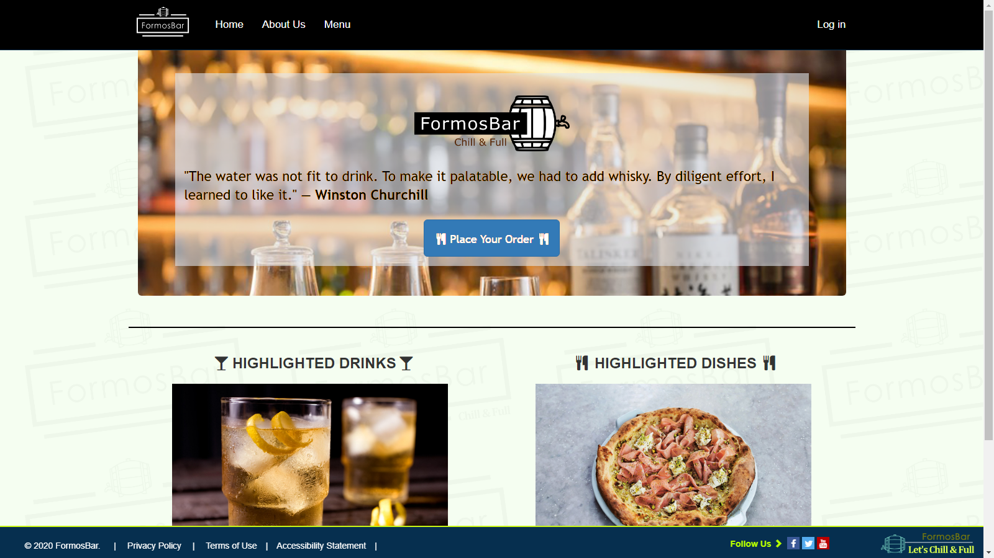

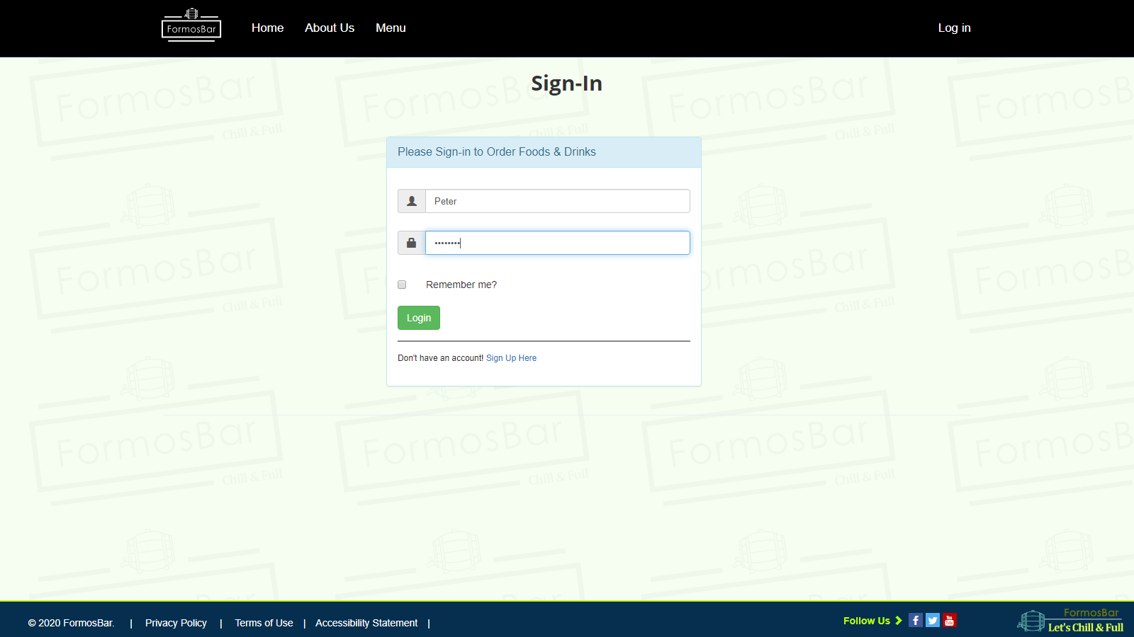

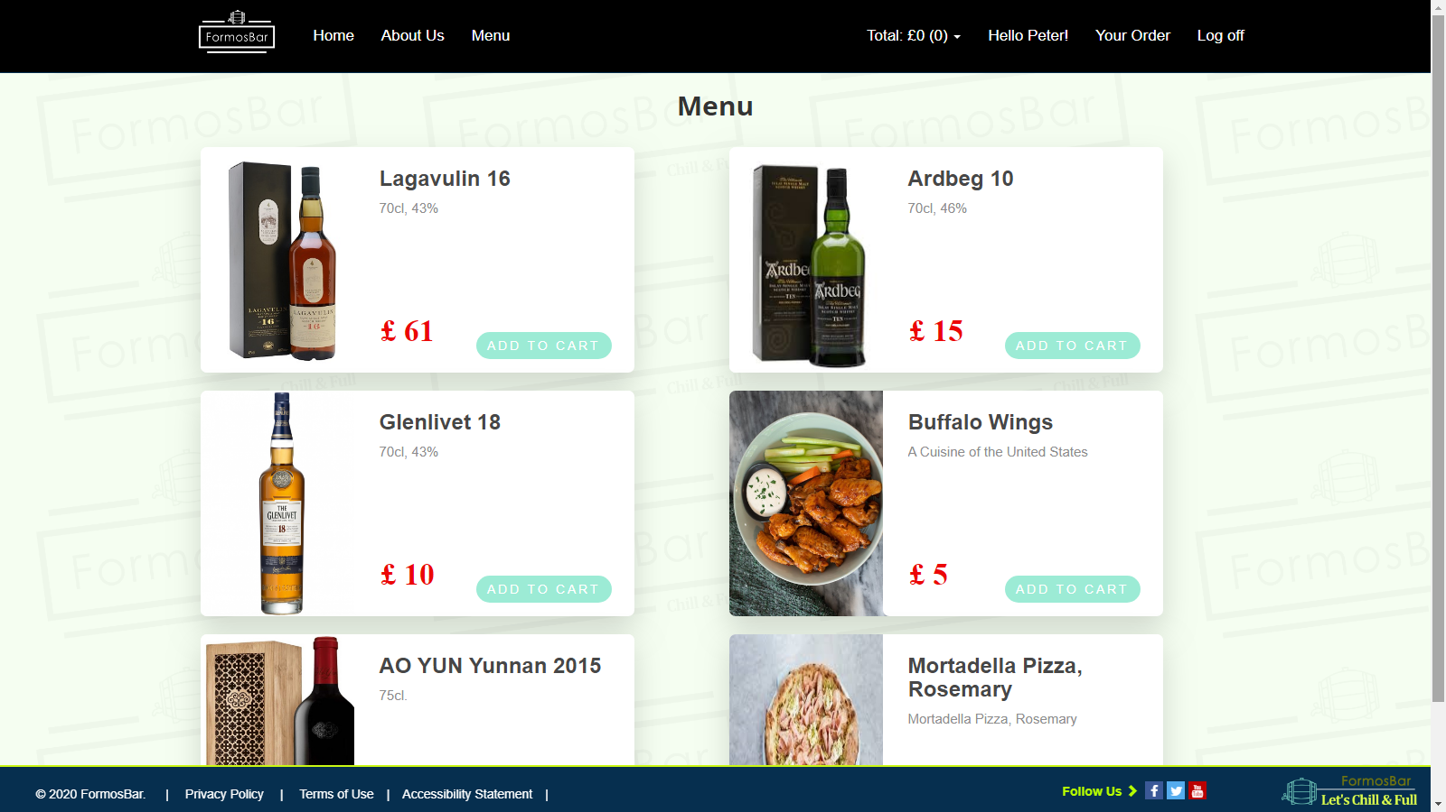

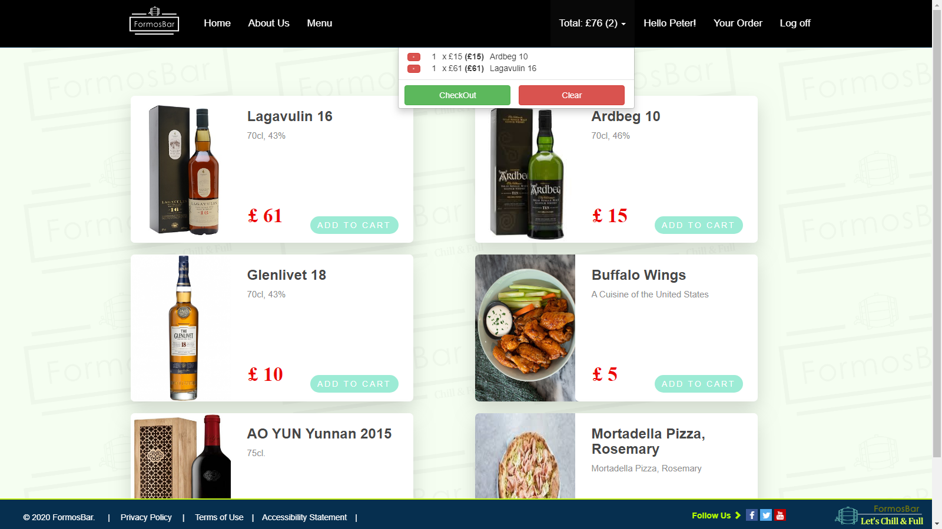

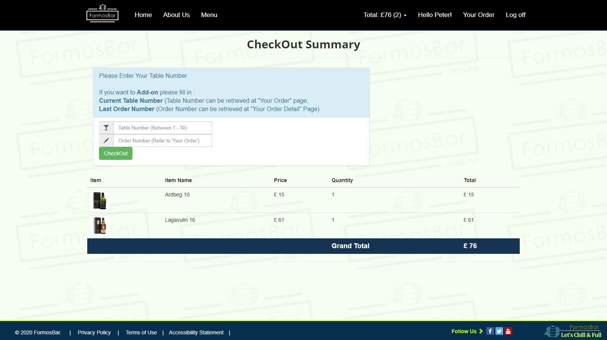

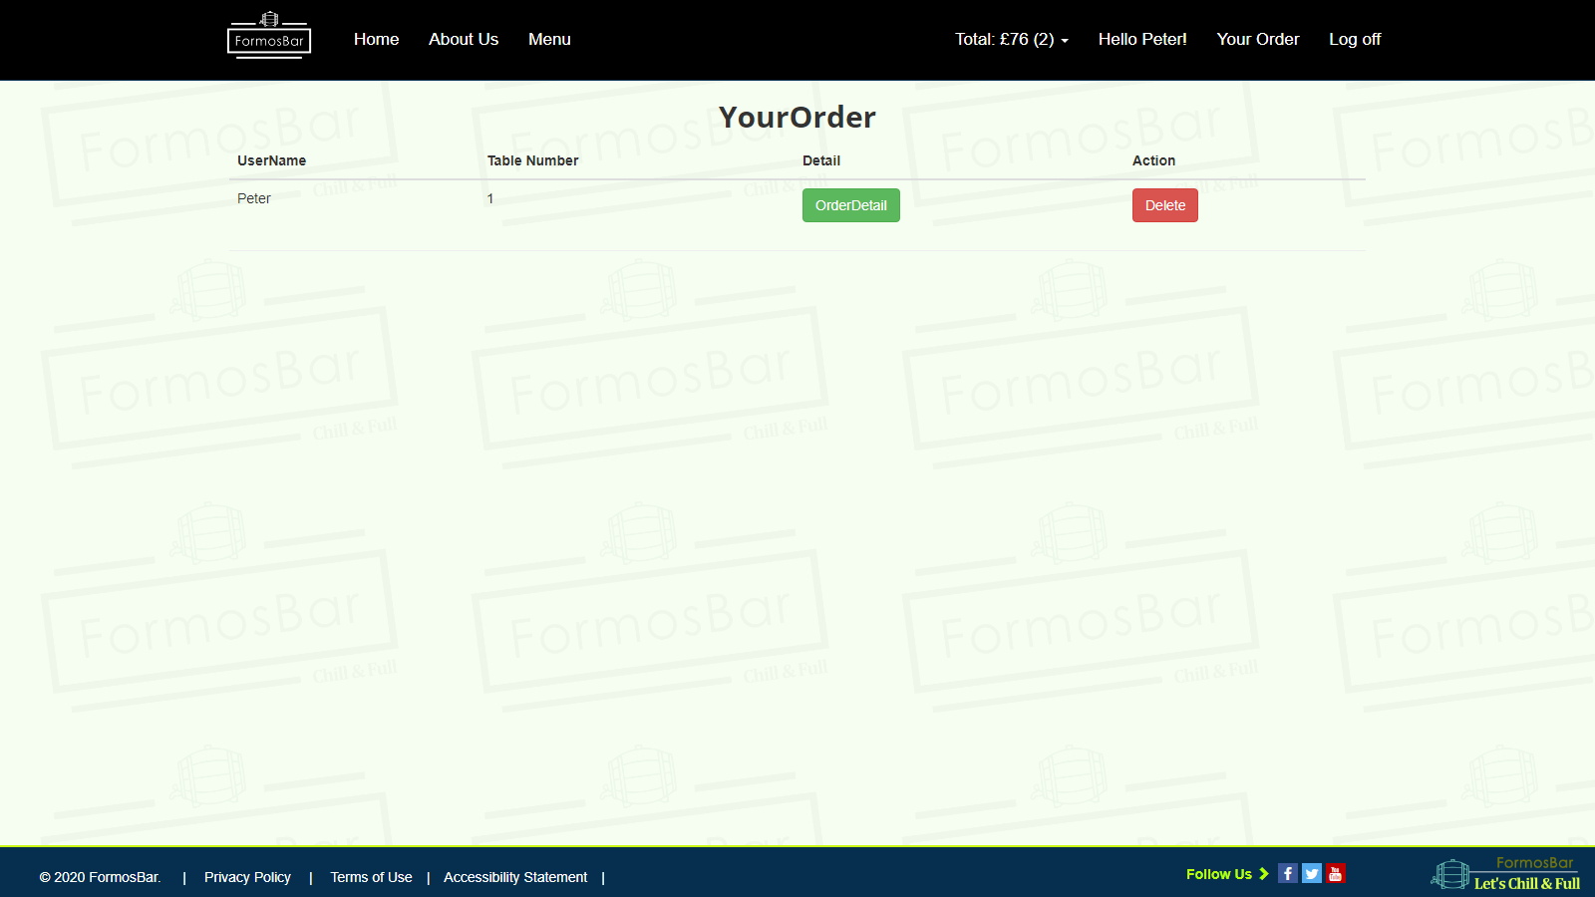

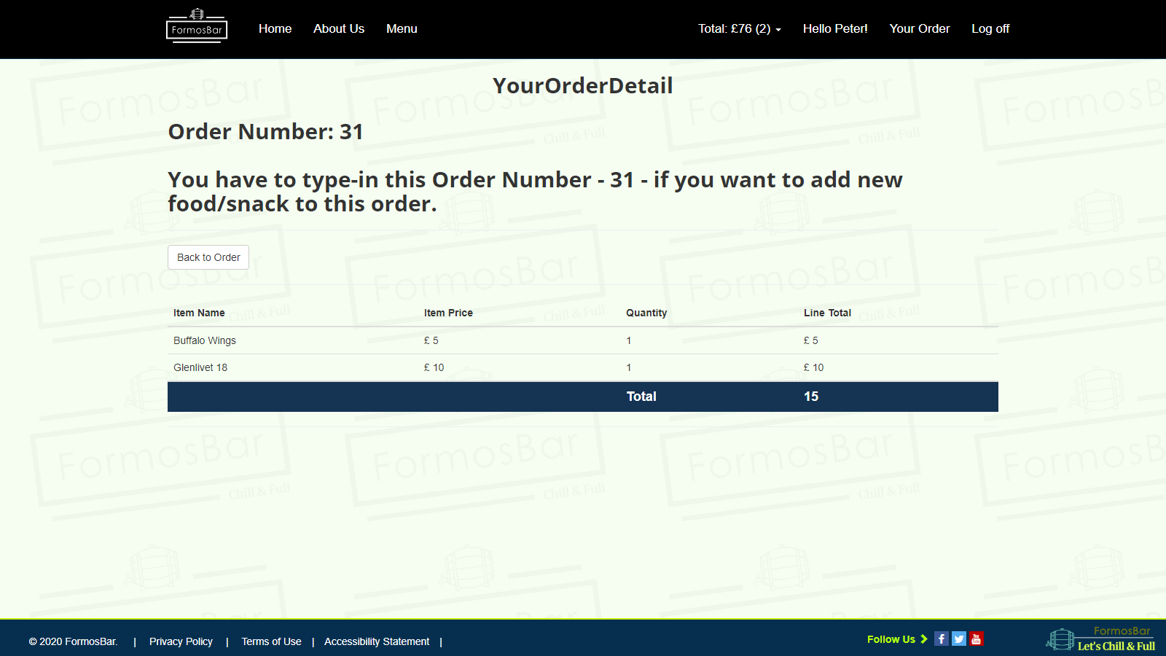

* Administrator View

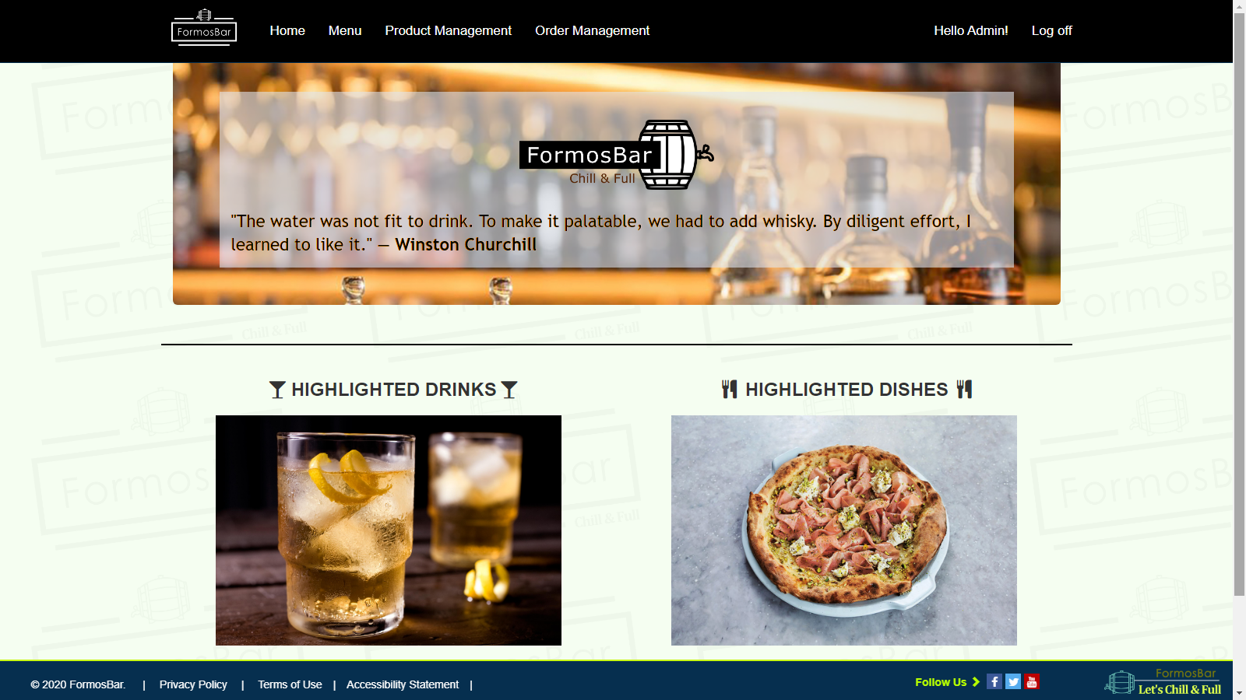

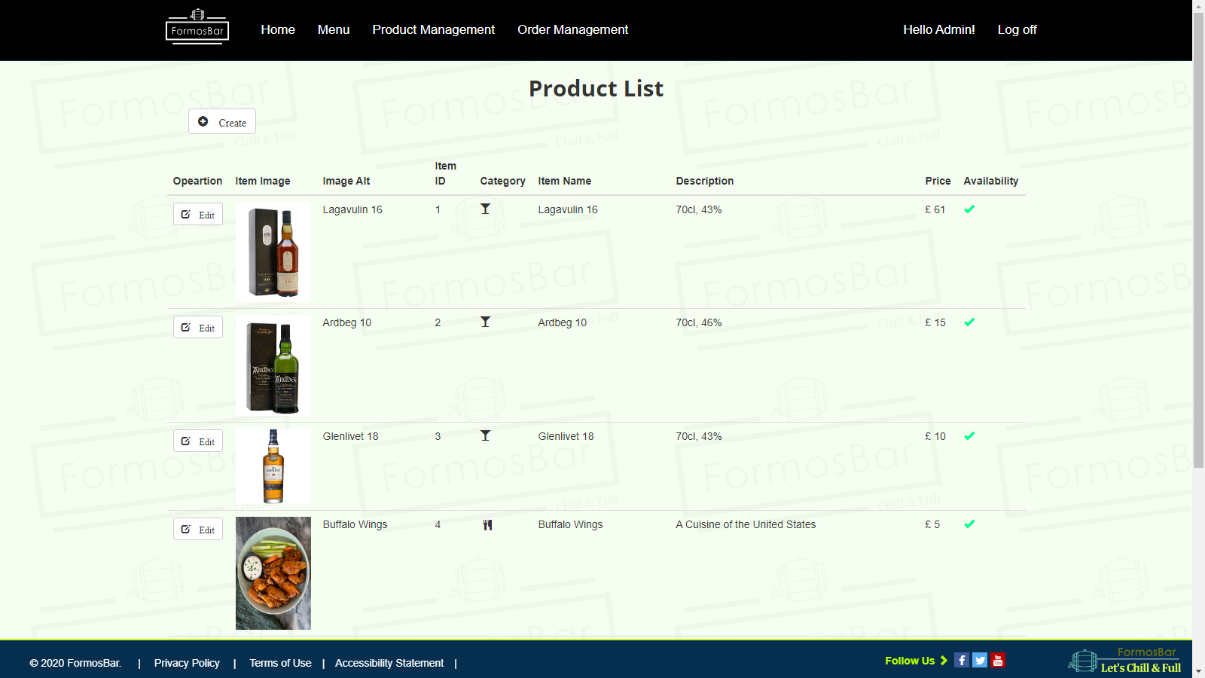

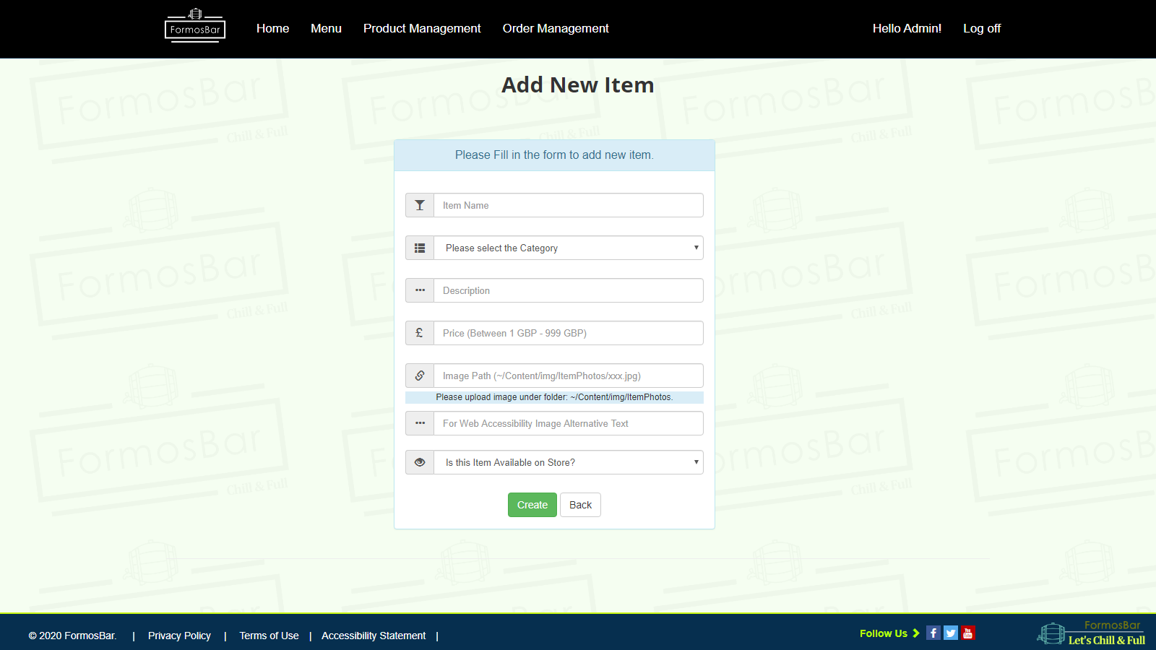

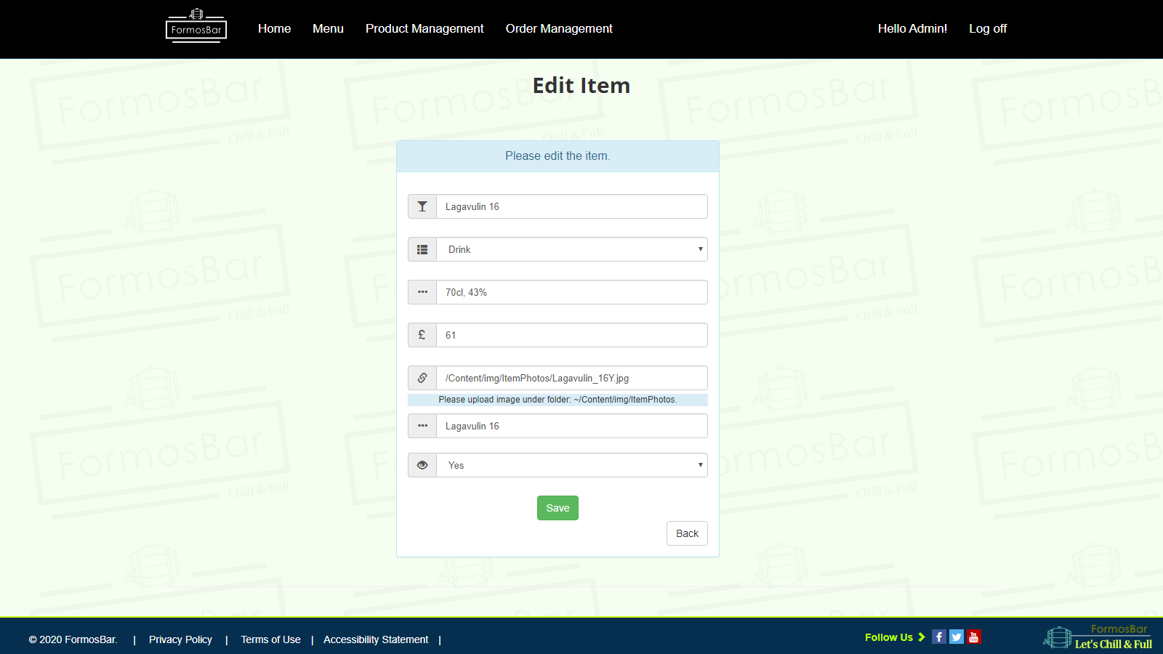

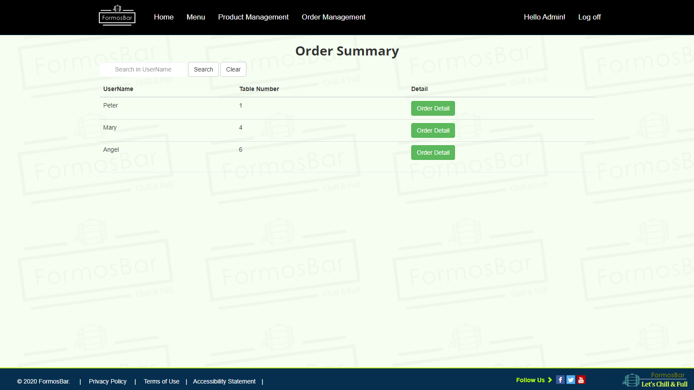

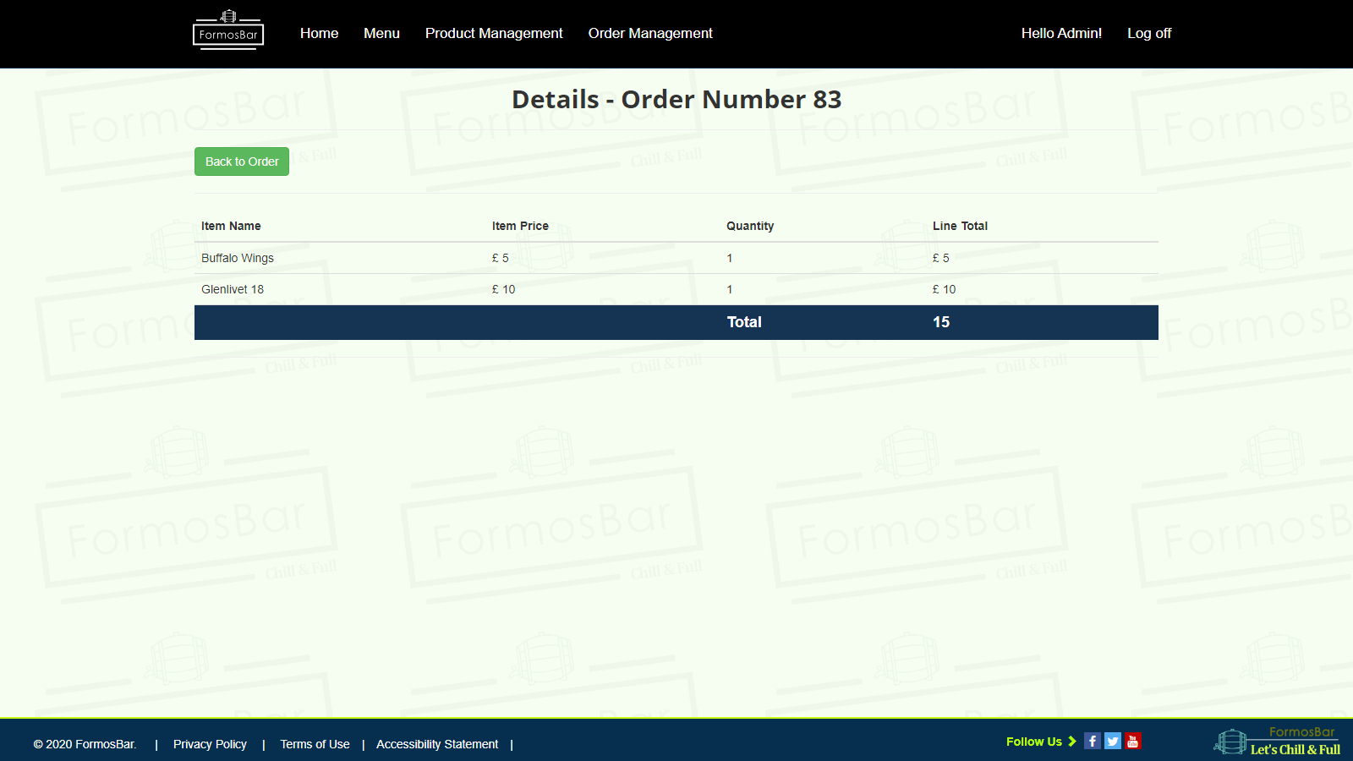

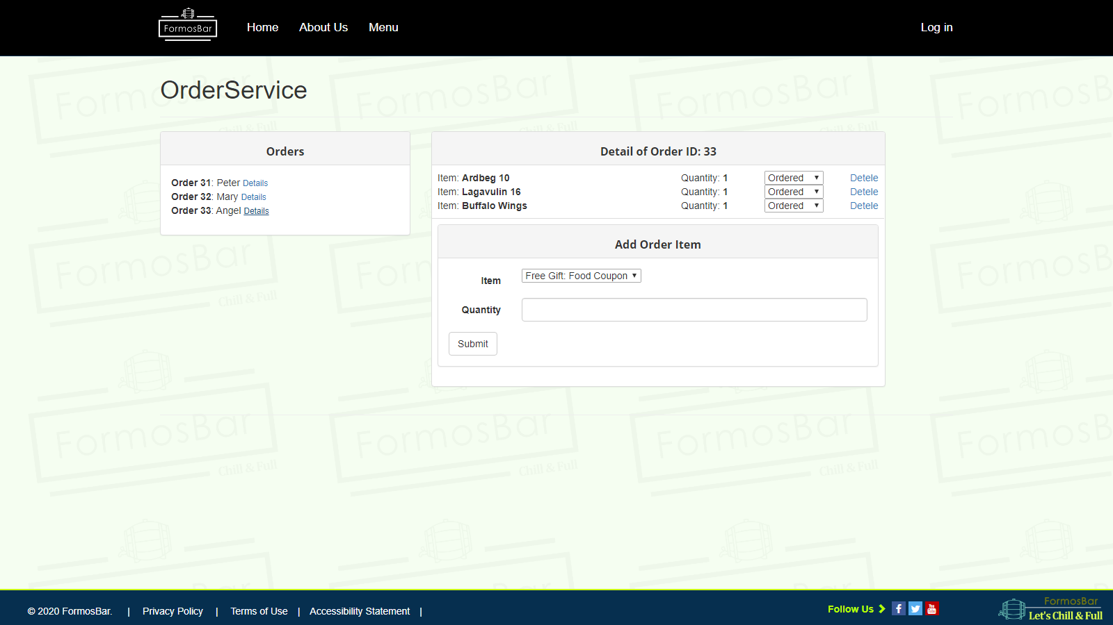

**Evidence of testing on more than one browser**

* Google Chrome  
    
  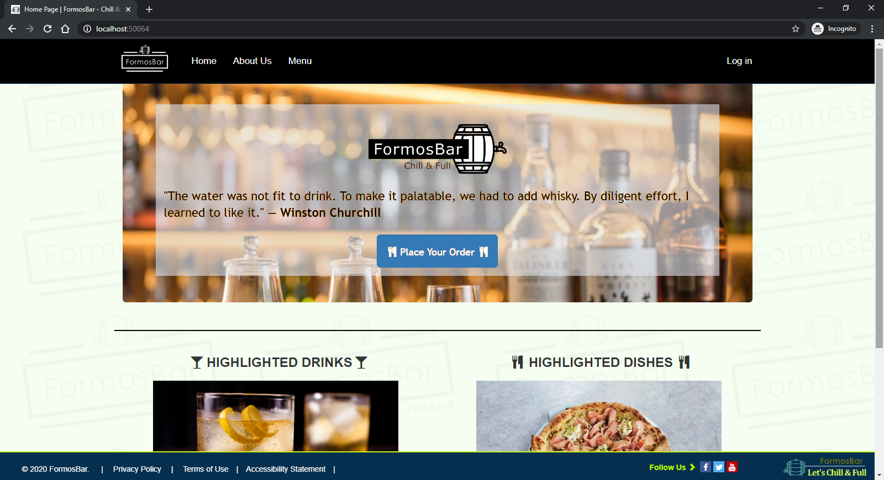  
    
  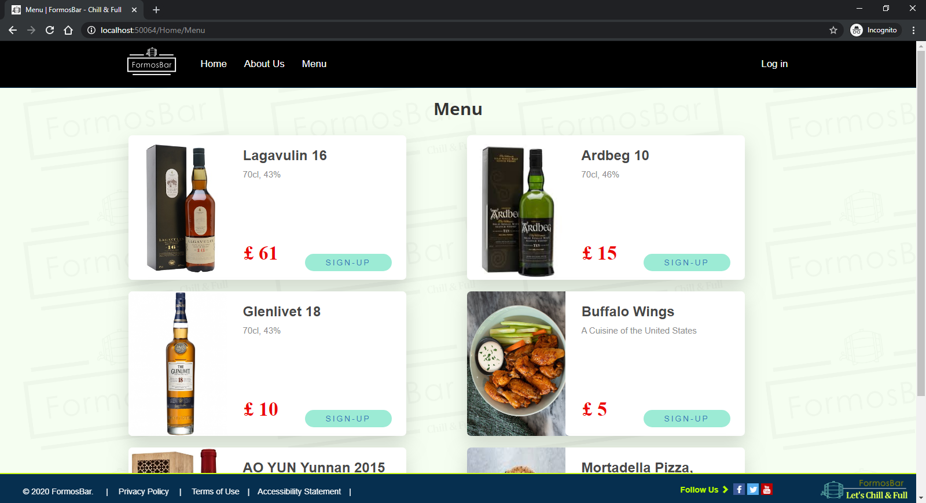
* FireFox  
    
  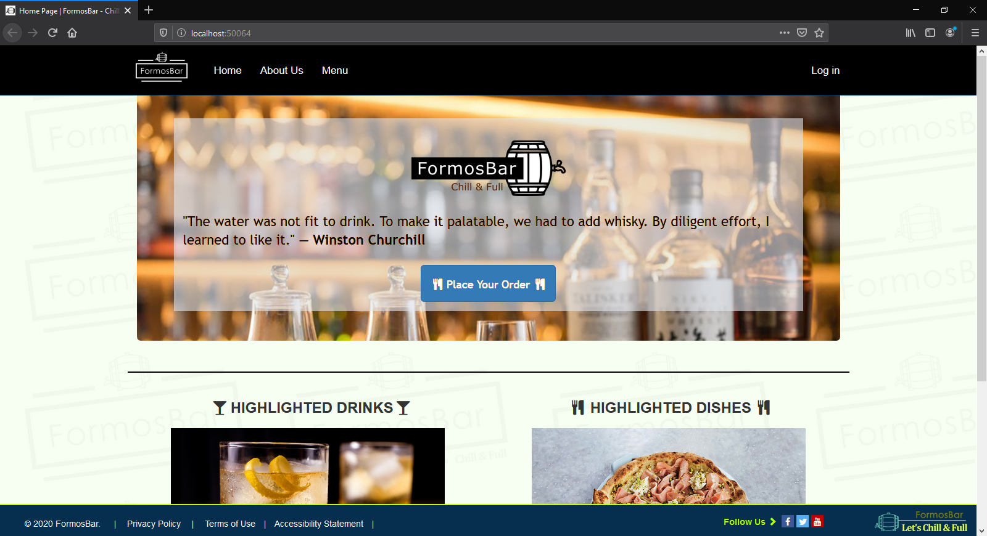  
    
  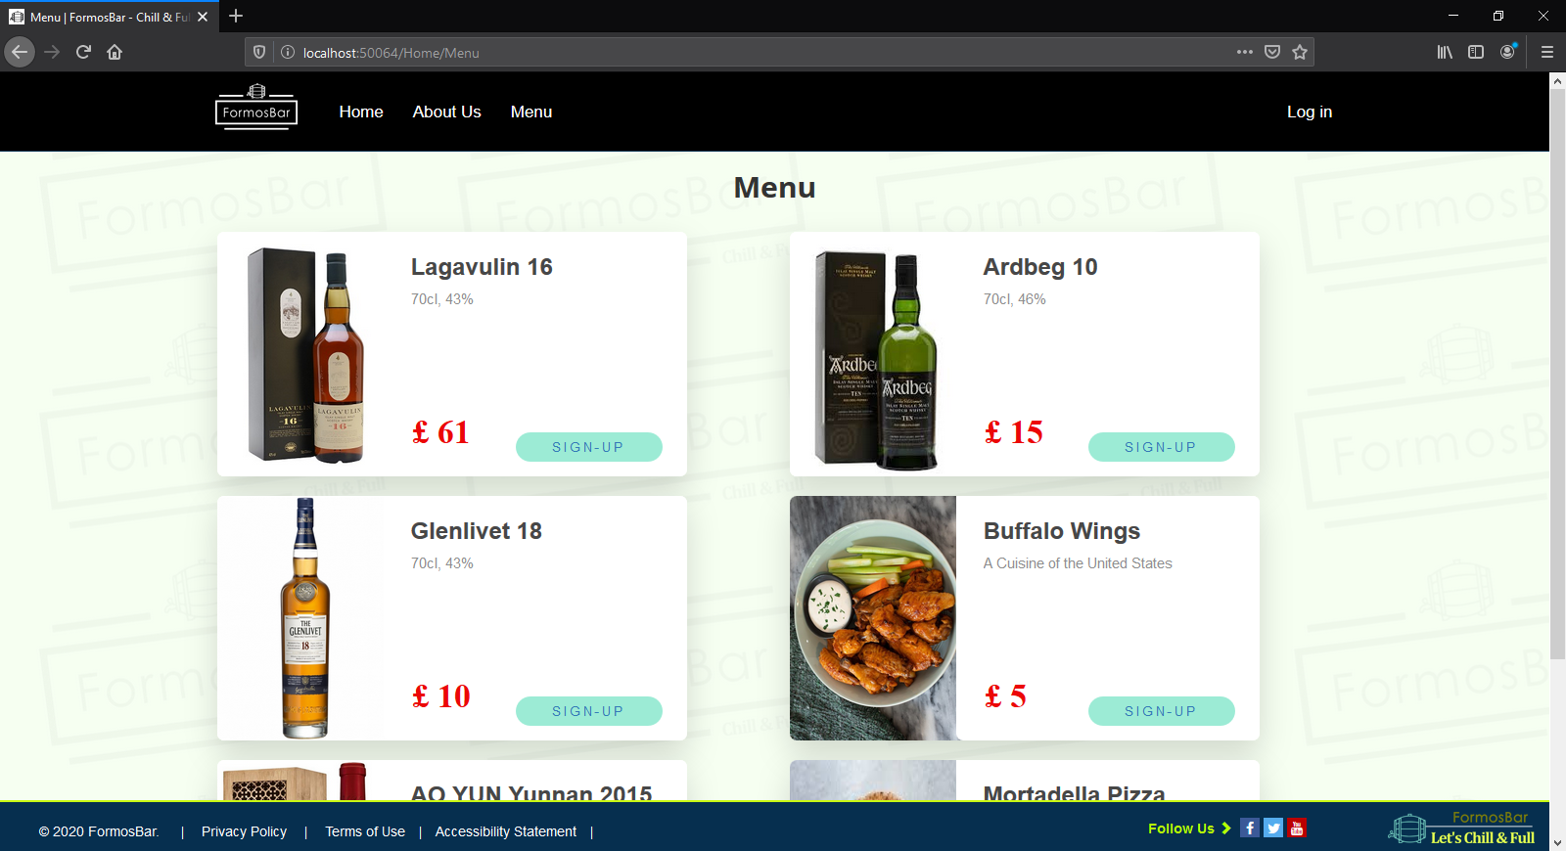

**Evidence of Web Accessibility testing and results**

